LOVELY PROFESSIONAL UNIVERSITY

**DEPARTMENT OF COMPUTER SCIENCE AND ENGINEERING**

**PHAGWARA, PUNJAB**



ARTIFICIAL INTELLIGENCE

**FACE RECOGNITION ATTENDANCE SYSTEM**

**SUBMITTED IN PARTIAL FULLFILLMENT OF REQUIREMENTS FOR THE AWARD OF**

# B. TECH

**COMPUTER SCIENCE AND ENGINEERING**

**SUBMITTED BY:**

**Amandeep Singh Owais Nabi Bhat Anurag Yadav**

**12101332 12100673 12101437**

**Roll no: 24 Roll No: 43 Roll no: 47**

TABLE OF CONTENTS

* WHAT IS FACE RECOGNITION?
* WHAT IS DOES
* HOW IT WORKS?
* TECHNOLOGY USED
* SOURCE CODE
* OUTCOME
* ADVANTAGE
* DISADAVANTAGE
* FUTURE PLANS
* SCOPE
* CONCLUSION

**Introduction:**

A face recognition system is an artificial intelligence (AI) technology that uses computer algorithms and machine learning models to identify or verify the identity of an individual by analyzing patterns and features on their face. The system captures an image of a person's face using a camera or other imaging device and then analyzes the image to determine if there is a match with a pre-existing database of faces.

The primary function of a face recognition system is to automate the process of identifying individuals, replacing traditional methods that rely on manual verification. The system can be used in various applications, including security systems, access control, and authentication.

The process of face recognition involves several stages, including image acquisition, image pre-processing, feature extraction, and matching. Image acquisition involves capturing an image of a person's face using a camera or other imaging device. Image pre-processing involves detecting and extracting the facial features, followed by feature extraction, where specific facial features such as the eyes, nose, and mouth are identified and marked. These features are then compared to a database of known faces to determine if there is a match.

Face recognition systems rely on a combination of several technologies, including computer vision, pattern recognition, and machine learning. The most commonly used algorithms in face recognition systems are Principal Component Analysis (PCA), Linear Discriminant Analysis (LDA), and Support Vector Machines (SVM).

Face recognition systems can be implemented using various hardware and software technologies, including digital cameras, 3D scanners, and facial recognition software. The technology has become increasingly popular and is being used in various applications, including security systems, access control, and authentication.

In conclusion, a face recognition system is an innovative AI technology that automates the process of identifying individuals by analyzing patterns and features on their face. The system relies on computer vision, pattern recognition, and machine learning algorithms to accurately identify individuals. The technology has become increasingly popular and is being used in various applications, including security systems, access control, and authentication.

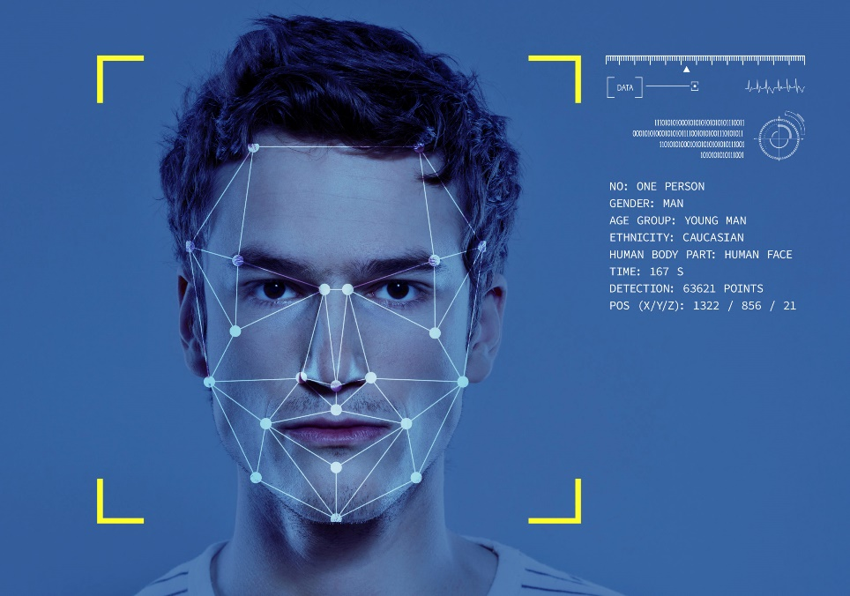**What It Can Do:**

A face recognition system is an innovative AI technology that can perform several functions related to identifying individuals by analyzing their face. Some of the things a face recognition system can do include:

* Identify individuals: One of the primary functions of a face recognition system is to identify individuals. The system captures an image of a person's face and compares it to a pre-existing database of faces to determine if there is a match.
* Verify identities: Face recognition systems can also verify the identity of an individual. The system compares the facial features of the individual to a pre-existing database of faces to confirm their identity.
* Access control: Face recognition systems can be used to control access to restricted areas. The system can verify the identity of an individual before granting them access to a secure location.
* Security systems: Face recognition systems can be used in security systems to detect and alert security personnel of unauthorized individuals attempting to access a secure location.
* Law enforcement: Law enforcement agencies can use face recognition systems to identify suspects in criminal investigations. The system can compare the facial features of suspects to a database of known criminals to help identify the perpetrator.
* Customer experience: Some businesses are using face recognition systems to provide a personalized customer experience. The system can recognize a customer and tailor the shopping experience to their preferences.

**How Does it Works:**

A face recognition system works by using computer algorithms and machine learning models to analyze patterns and features on a person's face to identify or verify their identity. The process of face recognition involves several stages, including image acquisition, image pre-processing, feature extraction, and matching.

Here is a breakdown of how a face recognition system works:

**Image Acquisition:** The face recognition system captures an image of a person's face using a camera or other imaging device. The image is then transferred to a computer or server for processing.

**Image Pre-processing:** The system analyzes the image and detects the location of the face within the image. The image is then pre-processed to correct for any variations in lighting or facial orientation.

**Feature Extraction:** The system extracts specific facial features such as the eyes, nose, and mouth from the pre-processed image. The features are then marked and converted into a set of numerical values or feature vectors.

**Matching:** The system compares the feature vectors of the image to a pre-existing database of faces to determine if there is a match. The matching process involves measuring the similarity between the feature vectors of the image and those in the database.

**Decision Making:** The system makes a decision based on the similarity score between the image and the database. If the similarity score is above a predefined threshold, the system will conclude that there is a match and provide the identity of the person in the image. If the similarity score is below the threshold, the system will conclude that there is no match.

Face recognition systems rely on various technologies, including computer vision, pattern recognition, and machine learning. The most commonly used algorithms in face recognition systems are Principal Component Analysis (PCA), Linear Discriminant Analysis (LDA), and Support Vector Machines (SVM).

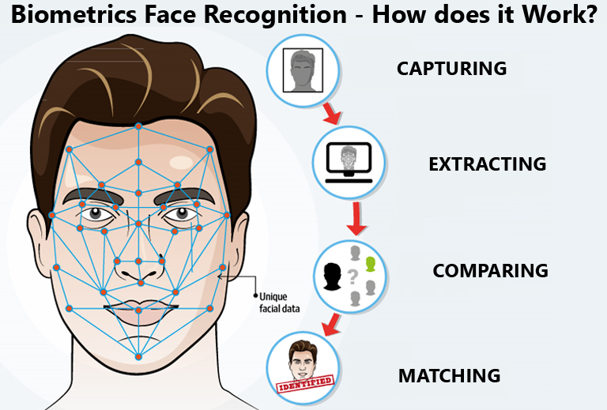

**Technology Used:**

A face recognition system is an advanced AI technology that requires complex algorithms, machine learning models, and libraries to analyze patterns and features on a person's face to identify or verify their identity. Here are some of the technologies and libraries used to create a face recognition system:

**OpenCV**: OpenCV is a popular computer vision library that provides developers with tools for image and video processing. It is used in face recognition systems for image acquisition, pre-processing, and feature extraction. OpenCV provides functions for face detection, facial landmark detection, and face alignment.

**Deep Learning**: Deep Learning is a subset of machine learning that involves training neural networks on large datasets. In face recognition systems, deep learning models such as Convolutional Neural Networks (CNN) and Recurrent Neural Networks (RNN) are used to identify and verify faces.

**Dlib**: Dlib is a popular machine learning library used for face detection, facial landmark detection, and face recognition. It provides developers with pre-trained models for face detection and facial landmark detection. It is also used for training custom face recognition models.

**TensorFlow**: TensorFlow is an open-source machine learning library developed by Google. It is used for developing and training deep learning models for face recognition systems. TensorFlow provides tools for building neural networks, optimizing models, and deploying models to production.

**PyTorch**: PyTorch is another open-source machine learning library used for developing deep learning models. It is known for its ease of use and flexibility. PyTorch is used in face recognition systems for training deep learning models for face recognition.

**FaceNet**: FaceNet is a deep learning model developed by Google that is used for face recognition. It uses a triplet loss function to train a neural network to encode faces into a 128-dimensional feature vector. This feature vector is then used to compare faces for identification or verification.

**SOURCE CODE:**

*Program.py*







**



**Attendance data**



**Added** **Images**

**OUTCOME:**



**Face recognition successful**



**Face recognition successful**



**Face recognition successful**

**Present person list:**

**Advantages:**

1. Increased Security: A face recognition system can provide enhanced security by verifying the identity of individuals in various settings, including airports, banks, and government institutions.
2. Convenience: Face recognition systems can provide a convenient and efficient way for individuals to access secure areas or information without the need for physical keys or passwords.
3. Improved Accuracy: Face recognition systems can achieve high levels of accuracy in identifying individuals, especially when compared to other biometric systems such as fingerprint or iris scanning.
4. Increased Efficiency: A face recognition system can automate certain tasks, such as employee attendance tracking or customer identification, leading to increased efficiency and productivity.
5. Reduced Fraud: Face recognition systems can reduce the risk of fraud, such as identity theft or impersonation, as it is difficult to forge a person's face.
6. Non-intrusive: Unlike other biometric systems, face recognition does not require physical contact, making it a non-intrusive method of identification.
7. Cost-effective: Face recognition systems can be cost-effective, as they do not require additional hardware such as fingerprint scanners or smart cards.
8. Improved Customer Service: Face recognition systems can help businesses provide improved customer service by quickly identifying customers and personalizing their experience.

**Disadvantages:**

1. Privacy Concerns: The use of face recognition systems raises concerns about privacy as it involves the collection and storage of personal data.
2. False Positives: Face recognition systems can produce false positives, identifying a person incorrectly as someone else.
3. False Negatives: Face recognition systems can produce false negatives, failing to identify a person correctly.
4. Biased Results: Face recognition systems can produce biased results due to the lack of diversity in the training data.
5. Lighting Conditions: Face recognition systems can be affected by poor lighting conditions, leading to inaccuracies in the identification process.
6. Environmental Factors: Face recognition systems can be affected by environmental factors, such as changes in temperature or humidity.
7. System Errors: Face recognition systems can be prone to system errors, such as software bugs or hardware malfunctions.
8. Cost: Implementing a face recognition system can be expensive, requiring significant investment in hardware and software.
9. Limited Access: Face recognition systems may not be accessible to individuals with certain disabilities or conditions, such as facial disfigurement or blindness.

Legal Issues: The use of face recognition systems may raise legal issues, such as data protection and privacy regulations, which must be carefully considered

**Future Scope:**

he future scope of face recognition technology is vast and promising. Here are a few potential areas where face recognition technology may be used in the future:

Improved security: Face recognition technology has already been used in security systems, but in the future, it could be even more prevalent. It could be used to monitor public spaces, such as airports and train stations, to help prevent crime and terrorism.

Personalization: Face recognition technology could be used to personalize experiences for users. For example, it could be used to create personalized recommendations in retail stores, or to customize the interface of a computer or smartphone based on the user’s face.

Healthcare: Face recognition technology could be used in healthcare settings to help identify patients and ensure that they receive the correct treatment. It could also be used to monitor the health of patients remotely, such as in telemedicine.

Marketing and advertising: Face recognition technology could be used in marketing and advertising to measure the effectiveness of campaigns. For example, it could be used to track the facial expressions of consumers while they view ads to determine their emotional response.

Law enforcement: Face recognition technology could be used by law enforcement agencies to help identify suspects and solve crimes. It could also be used to monitor crowds at public events, such as protests or sporting events, to help prevent violence and unrest.

Overall, the future of face recognition technology is likely to be characterized by continued innovation and expansion into new areas. However, as with any new technology, it is important to carefully consider the ethical and privacy implications of its use

**Human And AI:**

Face recognition technology is a rapidly growing field that has a significant impact on both humans and AI. The technology is a prime example of the interaction between humans and AI. It relies on AI algorithms to identify faces, but its application affects human privacy, security, and social interactions.

On the AI side, face recognition technology relies on deep learning models and neural networks to recognize facial features and patterns in images. These models can quickly analyze vast amounts of data and recognize individuals with high accuracy. As AI algorithms continue to advance, we can expect face recognition technology to become even more accurate and sophisticated, allowing for a wide range of applications in security, law enforcement, marketing, and more.

On the human side, face recognition technology raises ethical and social concerns. For example, facial recognition technology has been used to monitor people's movements in public spaces, raising questions about privacy and civil liberties. Additionally, there is a risk of AI bias and error, which can result in false identifications and perpetuate existing biases and prejudices.

As face recognition technology continues to evolve, it is essential to consider the impact on both humans and AI. Responsible development

**Conclusion:**

In conclusion, face recognition technology has come a long way since its inception and has proven to be a valuable tool in various industries such as security, law enforcement, and entertainment. It has significantly improved the accuracy and efficiency of identifying individuals, reducing the risk of errors that may occur through manual recognition.

However, the technology is not without limitations. The potential risks of misuse and violation of privacy are still a major concern. There is also a need for continued research and development to improve the accuracy of the technology, especially for diverse groups of people.

It is essential to ensure that the use of face recognition technology is in compliance with ethical and legal standards. As AI continues to evolve, the development of standards and regulations for its use in society will be critical.

Overall, face recognition technology has the potential to transform various industries and enhance the quality of life for individuals. Still, it is crucial to be mindful of its limitations and ethical implications, and to use it responsibly for the benefit of society.